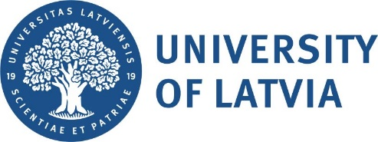 Baltic Studies: Courses
Bachelor Level
Autumn semester 2024
[02.09.2024. – 22.12.2024]
Course code | Course name | Lecturer | Credit points* | Day | Time | Place
JurZ6067 | International Media  Law | Prof. Artūrs Kučs  (arturs.kucs@lu.lv) | 3 ECTS
Vēst2102 | A History of Latvian Culture:  20th Century | Lect. Edgars Engīzers | 3 ECTS
Vēst2105 | A History of Ethnic Minorities in Latvia | Lect. Inese Runce | 3 ECTS
VidZ1000 | Environment and Sustainable Development in the Baltic Sea Region | Doc. Jānis Zaļoksnis | 6 ECTS
VidZ1033 | Climate and Sustainable Development | Doc. Jānis Zaļoksnis | 3 ECTS
*One Latvian credit point corresponds to 1.5 ECTS credits

